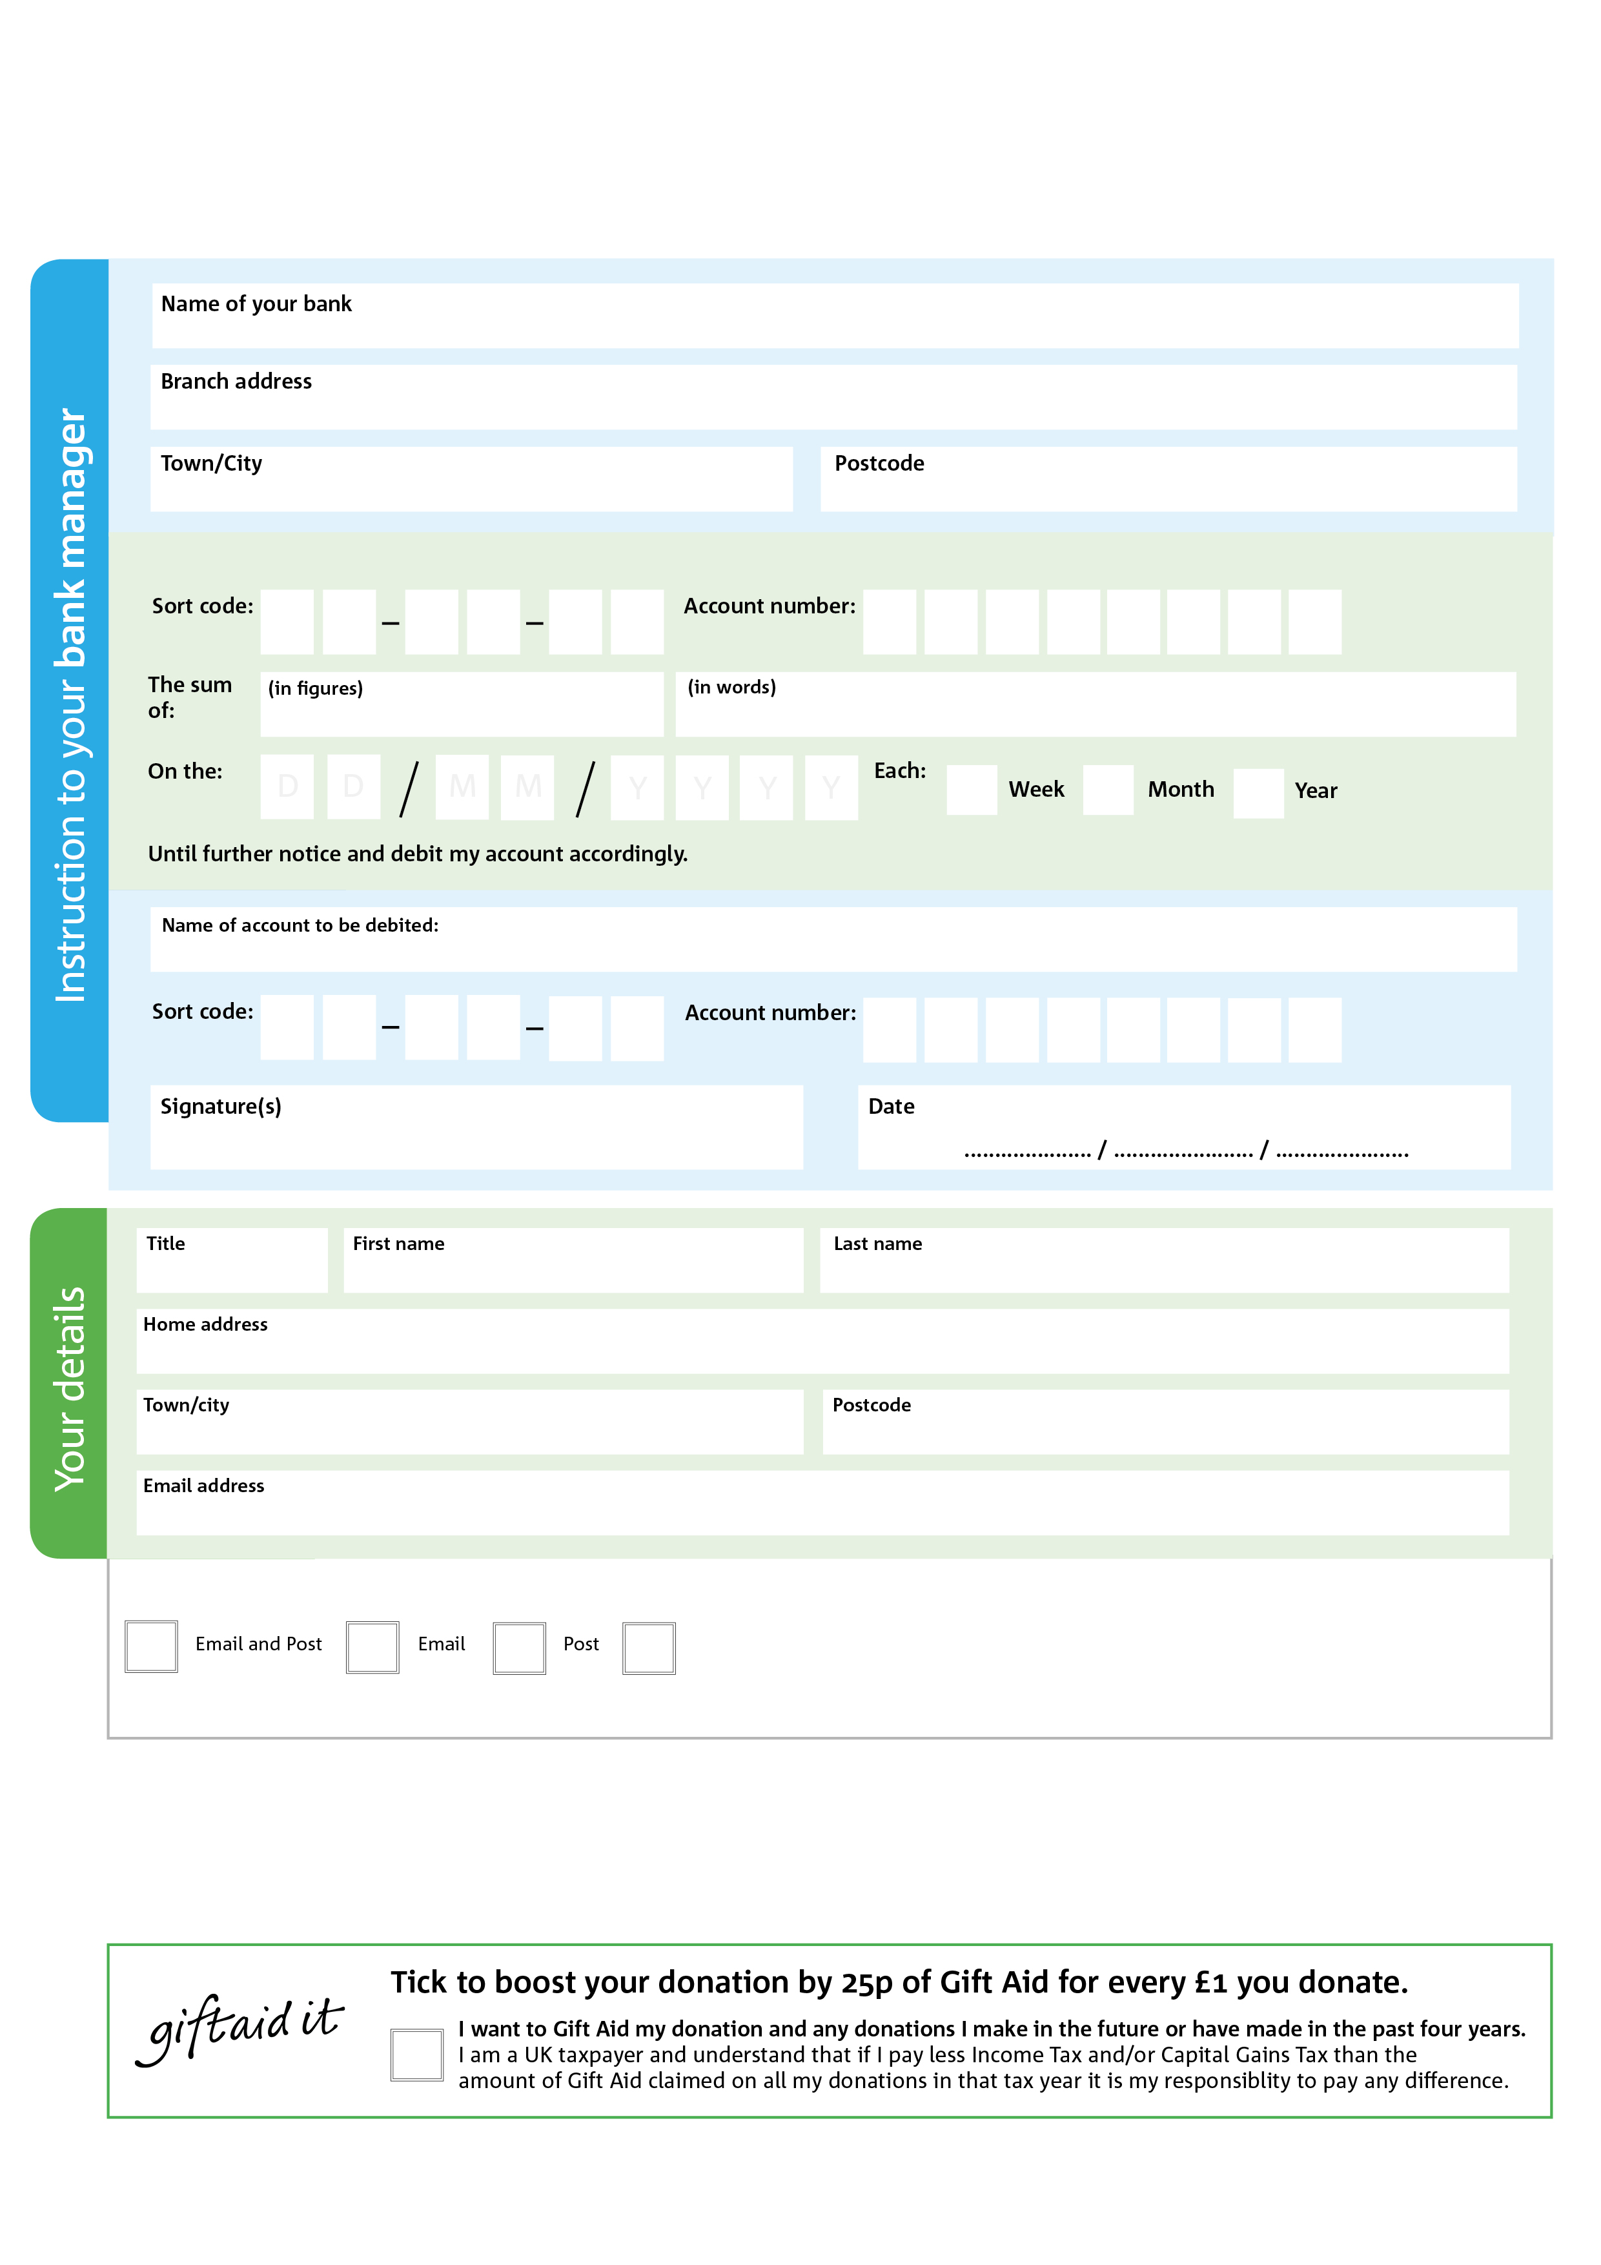

Please pay Kingsgate Community Church – Peterborough Foodbank

0

0

Please notify the charity if you: change name or address, want to cancel the declaration, or no longer pay sufficient tax on your income

POSTAL ADDRESS: Peterborough Foodbank, 2 Staplee Way, Peterborough, PE1 4YT



**Please pass this form onto the foodbank, using the foodbank’s address at the bottom, who will save a copy for their records. They will then send it onto your named bank or building society.**

5

V

5

V

8

V

8

V

6

V

7

V

0

V

4

V

7

8

2

0

2

We would love to keep you up to date with information about Peterborough Foodbank. Please tick your preference:

You can change your preferences any time by emailing us at info@peterborough.foodbank.org.uk

I do not wish to receive future communications from Peterborough Foodbank

**Data protection**

*Peterborough Foodbank is committed to protecting your privacy and will process your personal data in accordance with current Data Protection legislation. Foodbank collects information to keep in touch with you and supply you with information relating to our work. To unsubscribe from our newsletter, send a message to the email address above with the word unsubscribe in the subject line. A full data privacy statement for financial donors is available from the foodbank on request.*

**Standing Order Mandate**

**peterborough.foodbank.org.uk**

Reg. Charity No: 1106273 | Reg. in England & Wales

You can change your preferences any time by contacting us on XXXXXXXXXXX or emailing us at XXXX@XXXXXXXXXX.foodbank.org.uk

I do not wish to receive future communications from XXXXXX Foodbank