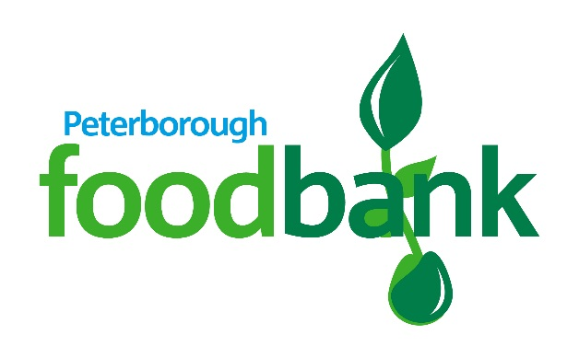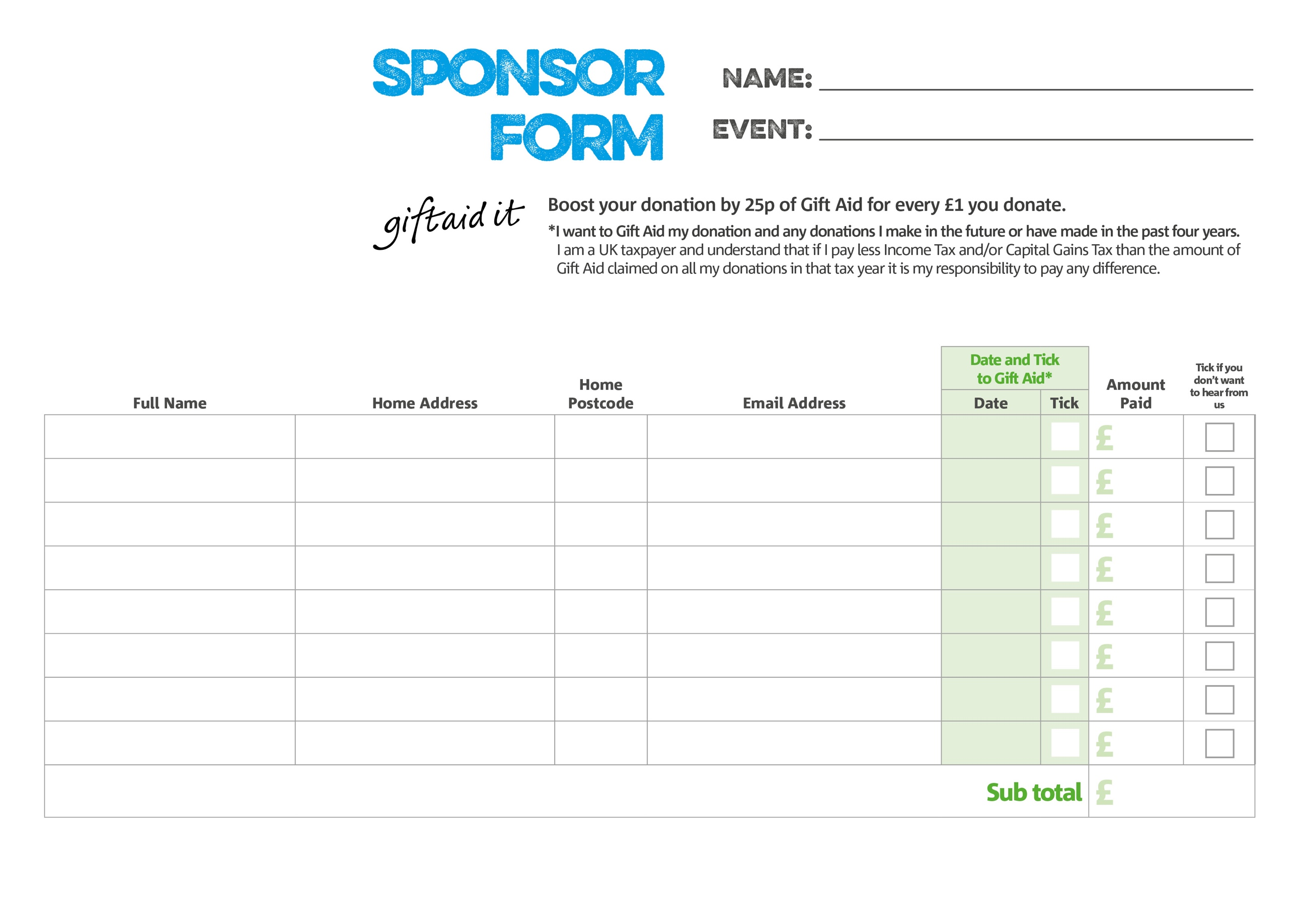

**Please make cheques payable to Peterborough foodbank**

**Peterborough foodbank | Registered Charity Number: 1106273 Registered in England & Wales**Your data will only be used by the foodbank for gathering sponsorship. It will be destroyed after sponsors’ payments have been received.   
It will not be given or sold to any other organisation. A data privacy statement for financial donors is available from the foodbank on request.

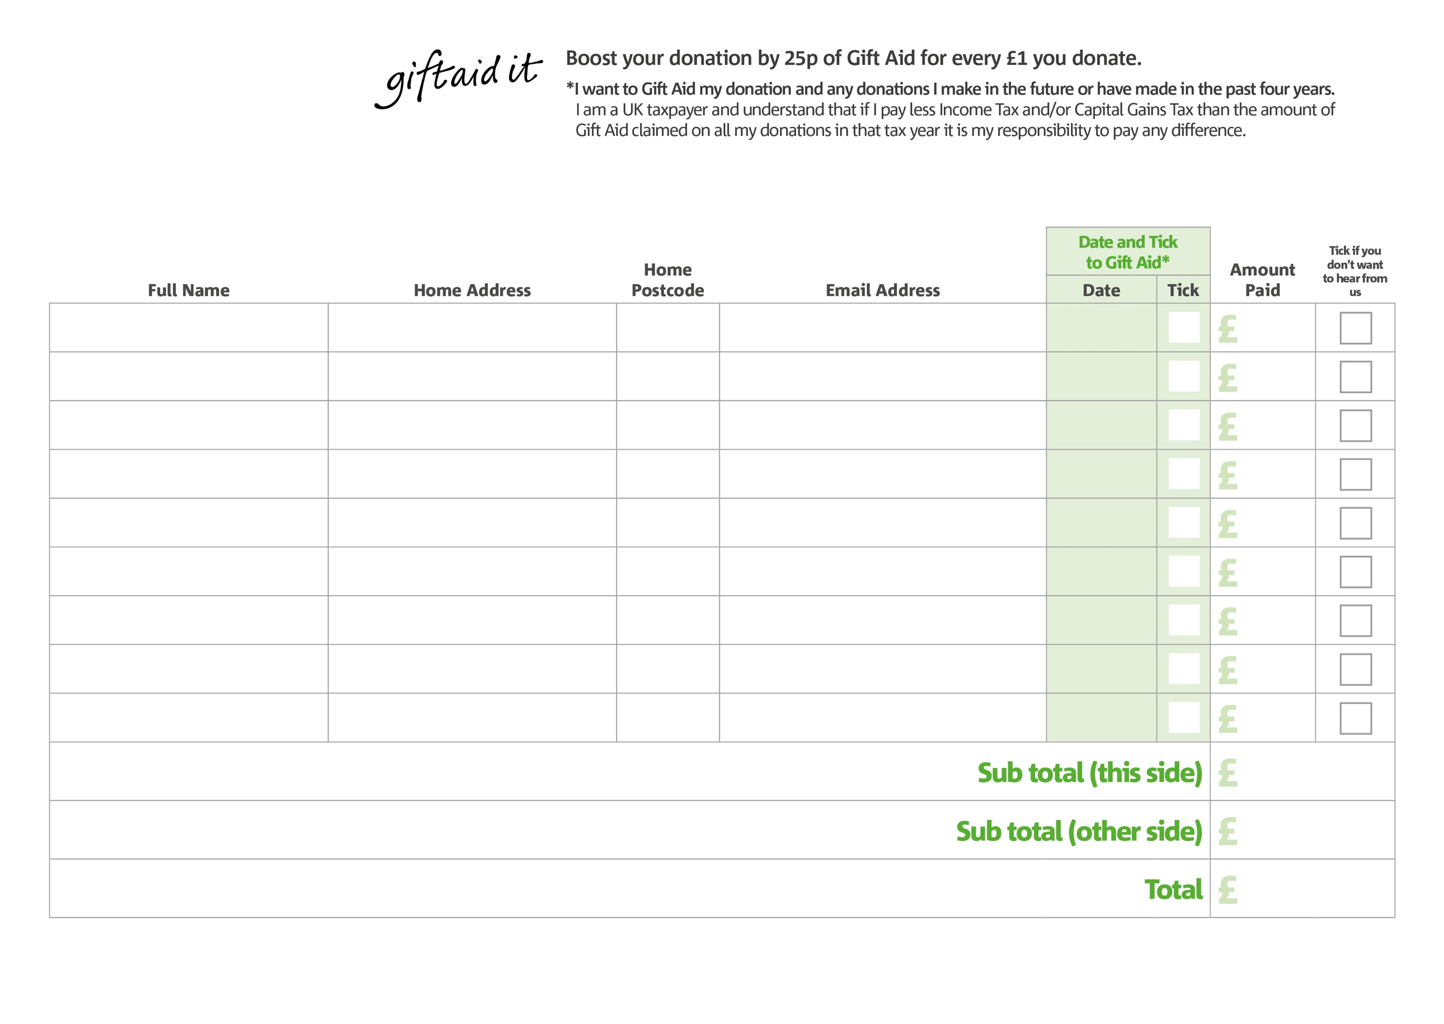

**Please make cheques payable to Peterborough foodbank**

**Peterborough foodbank | Registered Charity Number: 1106273 | Registered in England & Wales**Your data will only be used by the foodbank for gathering sponsorship. It will be destroyed after sponsors’ payments have been received.   
It will not be given or sold to any other organisation. A data privacy statement for financial donors is available from the foodbank on request.